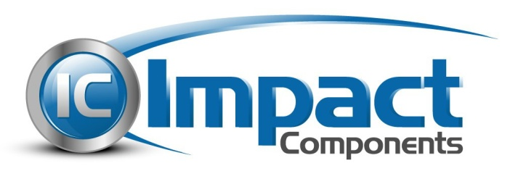

IMPACT Components Compliance with REACH

IMPACT Components supports the basic aim of REACH in improving the protection of human health and the environment through the better and earlier identification of the intrinsic properties of chemical substances.

According to our current state of knowledge, our products and packing materials do not contain any of the substances in amounts greater than 0.1 weight-% that are part of the list of SVHC (EC 1907/2006).

This information is provided based on reasonable inquiry of our suppliers and represents our current actual knowledge based on the information provided by our suppliers.

We expect this information will evolve over time, thru improved information gathering provided by our suppliers, and thru our own internal investigations.

